# How to Access and Configure PageProIP Devices

Connect your laptop to the PBX network and assign it a safe IP address

Open the VIP-102B management software

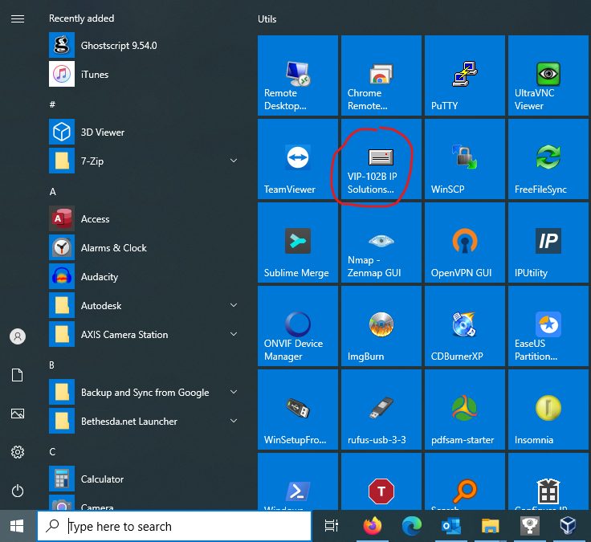

The default selection on the initial scan dialog should be fine as long as your laptop IP is on the same subnet as the PageProIP. Click OK to begin the scan for PageProIP devices.

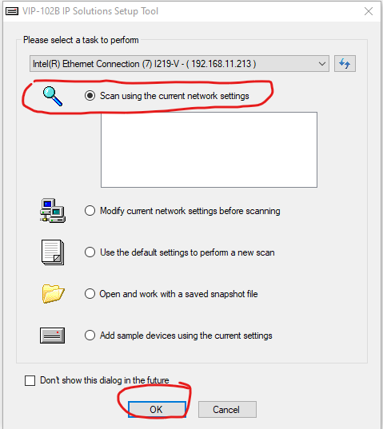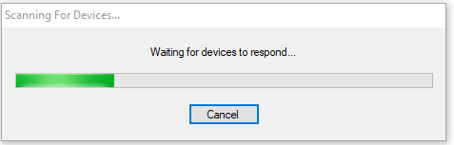

Once the device is detected, click Continue.

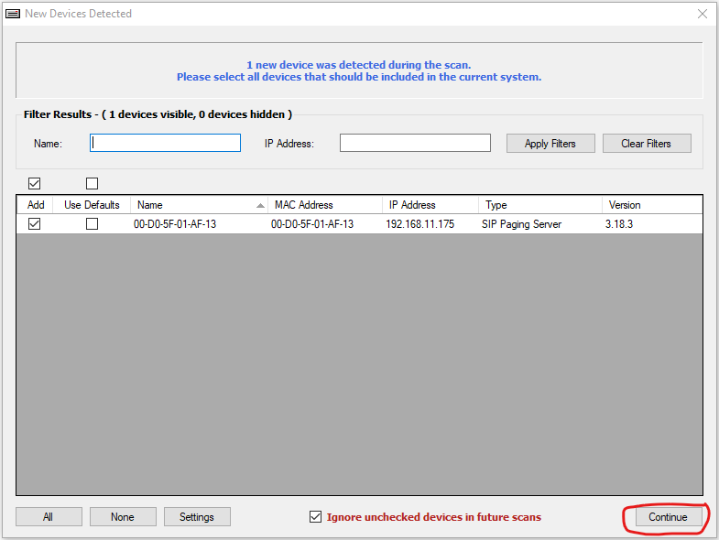

Data from the device is retrieved, click on the device in the left pane to display and edit the configuration

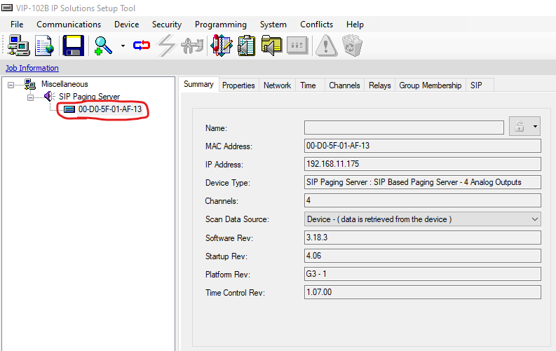

Click on the SIP tab and you can see that it is possible to register this demo device to up to 8 different PBX extensions. Yours will likely already be registered to two extensions, one for working spaces (normal page) and one for working spaces AND sleeping areas (emergency page). If you have already created new extensions in your PBX for these purposes, you can now edit the PageProIP so it will successfully register. Be sure to accurately fill in the Phone Number, Authentication Name (the extension number), Secret (extension password as entered on the PBX), the SIP Server IP address (PBX IP address), check the box labeled Register, assign it to an audio group (which will be associated with one of the 4 audio outputs) and you will probably want to check the box labeled Store and Play to avoid feedback. Repeat this process on the next tab to register your 2nd page extension.

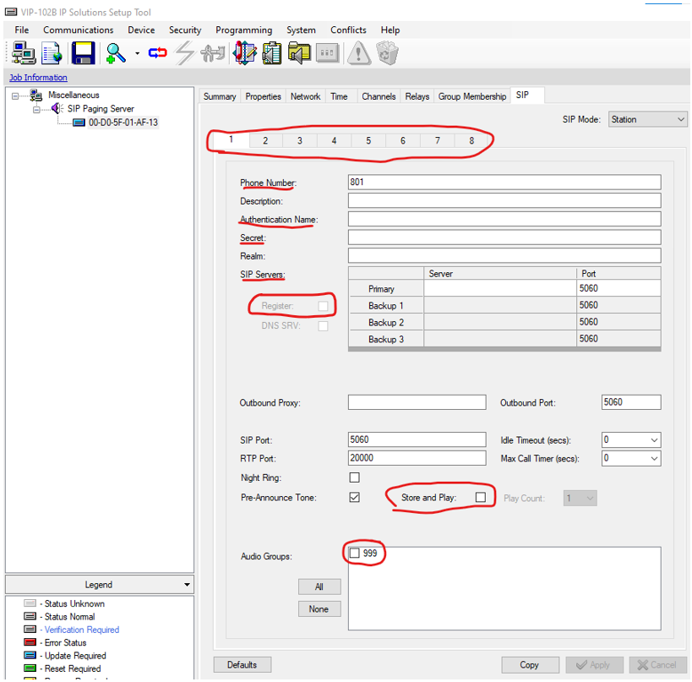

In this example, I am going to register to extension 401. I also decided to limit the Max Call Timer to 60 seconds in case someone doesn’t hang up the phone properly after making a page. Click Apply when finished.

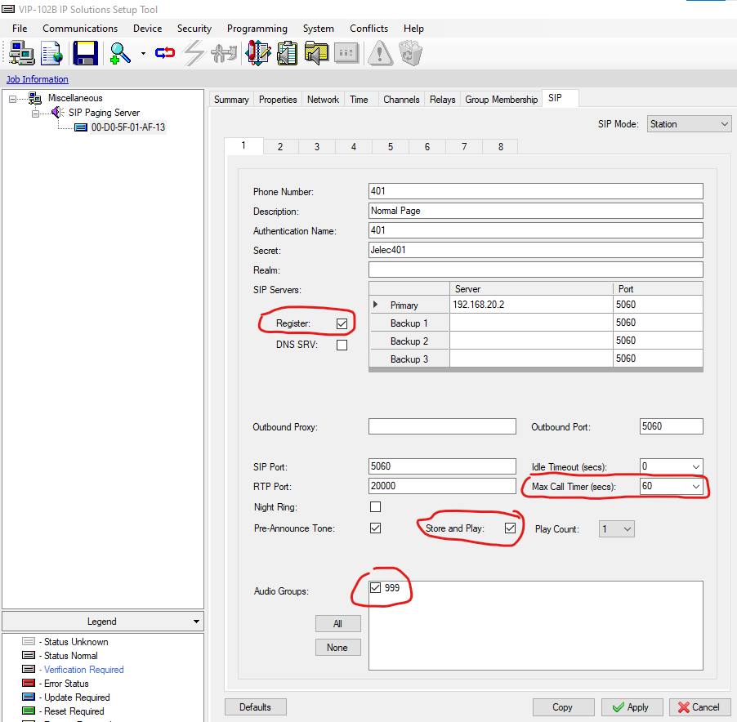

Click on the Group Membership tab and make sure the group you selected is assigned to the correct audio channel on the back of the device. This will depend on how your device is physically wired to the PAGA system and will also depend on how the programming of the PAGA routes the audio on that channel. If you picked the wrong Group, just go back to the SIP tab, and change groups. Don’t forget to click Apply if you made changes.

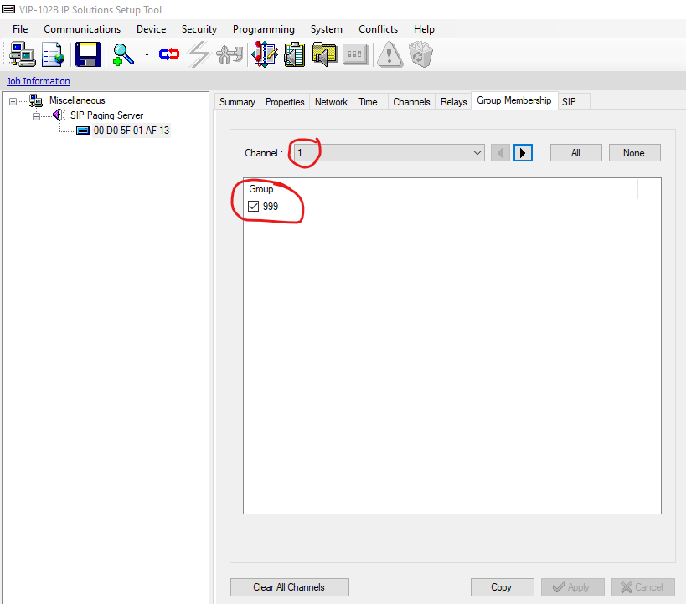

Lastly, you will want to click on the Channels tab and edit the Dial Code to your chosen extension, optionally add a Description and you have the opportunity to adjust the volume of the pages sent to this channel. Click Apply when finished.

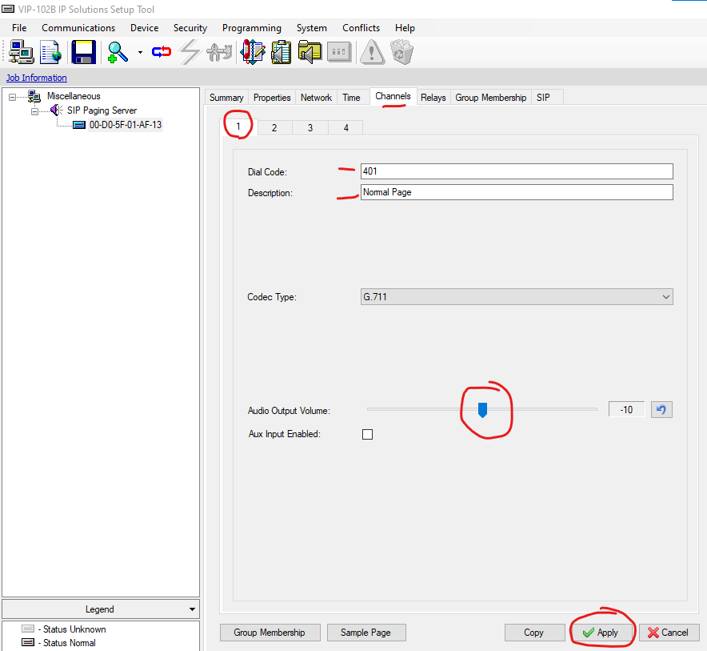

If you were simply making some changes to an existing/working system, that is all you really need to edit, but we’re not done yet! We still need to update the PageProIP device with all the config changes we just made as indicated by its blue icon. Do this by right-clicking on the device in the left column and select Update Device. Select Yes on the next two dialog boxes to update and reboot the device.

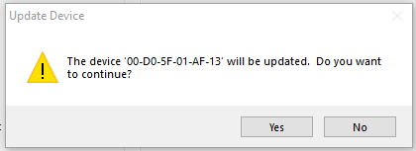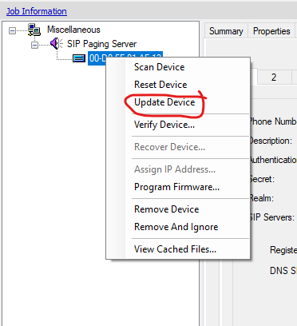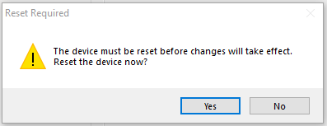

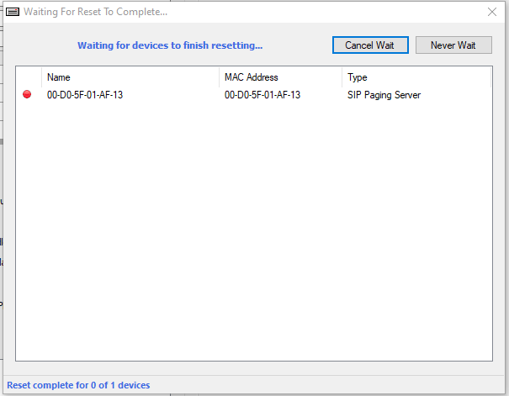

A gray icon now indicates that the device config matches the settings now displayed in the application

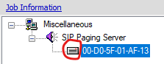

If you did everything correctly, you should notice that the extension is now properly registered on your PBX. Congratulations! Now test the paging system and make sure everything works.

